Exp. 4. Kronig Penney Model
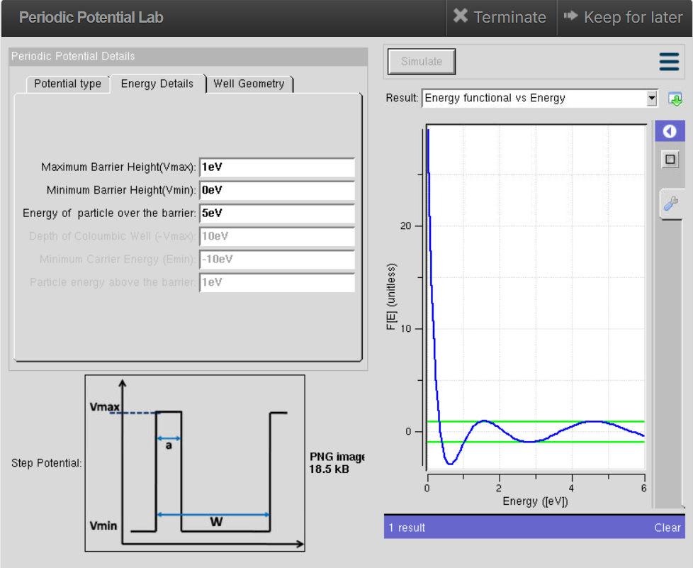
The Kronig-Penney Model is used to study the behavior of electrons in a periodic crystal structure. It helps understand how energy bands and band gaps are formed in semiconductor materials.

Case Study 1: Simulate the output for Triangular well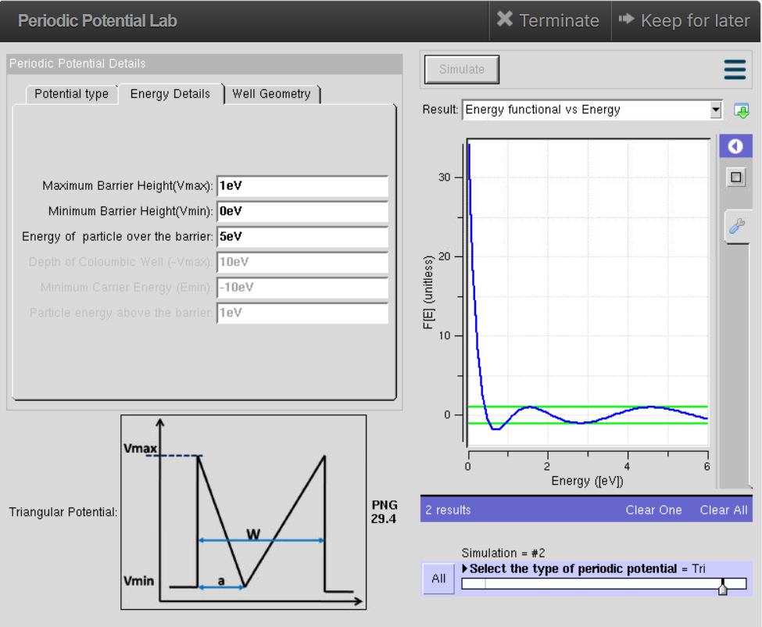

A triangular well is simulated to study the energy levels of electrons under a non-uniform potential. It helps understand how the shape of the potential well affects electron confinement and energy states.

Case Study 2: Simulate the output for Sinusoidal Potential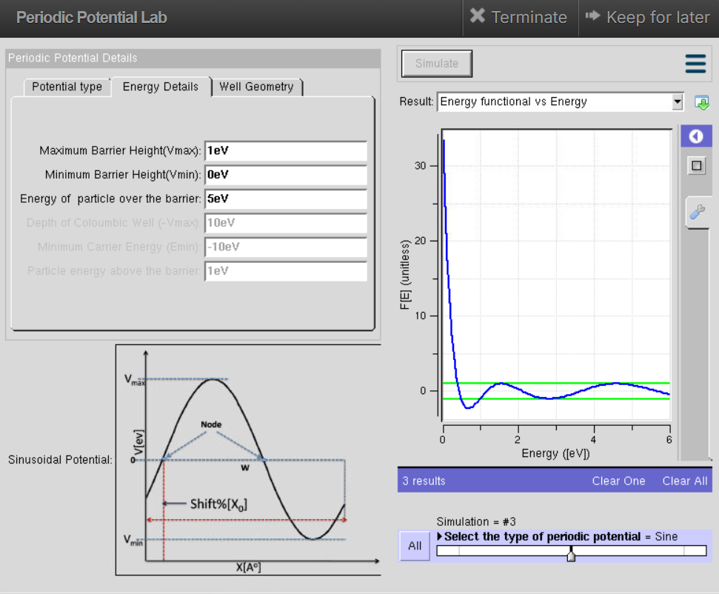

A sinusoidal potential is simulated to study the behavior of electrons in a periodically varying potential field. It helps understand how the periodic potential affects electron energy levels and wave functions.

